YEAR 11 STUDENTS ONLY
2 Students will be chosen to represent Mount Lilydale Mercy College
AMSSA STUDENT CONFERENCE 22 - 26 SEPTEMBER 2018
Santa Maria College | Perth, Western Australia
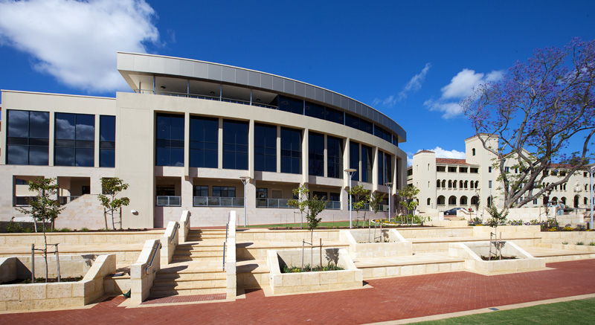
Some of the planned activities include:
The Student Conference will be held at Santa Maria College, nestled in picturesque gardens overlooking the Swan River in Attadale, Western Australia. Santa Maria College is located 15 kilometres from the Perth CBD and approximately a 30 minute drive from Perth Airport. Students will be accommodated in the boarding facilities at the College for the duration of the Conference.
On Mercy Day students will journey up the Swan River by ferry, following in the footsteps of Ursula Frayne and her companions and have the opportunity to explore on foot how the Mercy story flourished in the City of Perth. Mercy Day celebrations will conclude at Mercedes College, the oldest continuing girls’ school in Australia, located at Victoria Square Perth, the original site of foundation.
Other activities include:
Guest speakers addressing their personal formation stories that are founded in Mercy
Heritage Marketplace, sharing our Mercy foundations
Applications should take the form of a letter stating what being part of a mercy community means to you, how you have contributed to our mercy community during your time at the College and why you should be chosen to represent Mount Lilydale Mercy College. Please place these in a sealed envelope marked for the Attention of Miss keogh and hand in to student reception. Please sign the sheet when you hand these in. The College will cover costs other than spending money
Applications close end of lunch Tuesday 19 June 2018

