Year 10 Geography soil erosion fieldwork
Group 3 (Jude, Amelia, Kaitlyn, Scarlette, Bridgette, Alysha, Charlotte)

Soil analysis: Before we began the field work we did a soil analysis to find out the PH level of the soil. We discovered that it had a Ph level of 5-6 which was in the perfect range to sustain a plant.

Timeline | Photo | Observations
Before | 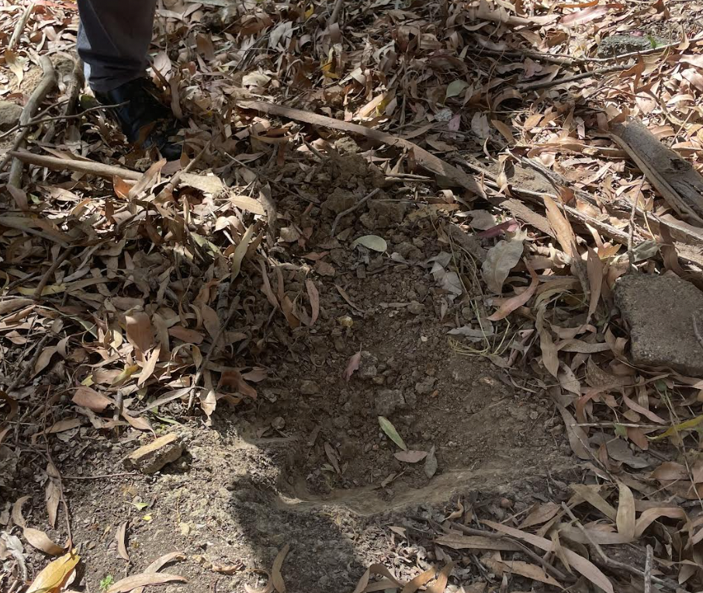 | - Initially, we observed that the soil was quite dry which was further emphasised through our inability to dig the soil. It was clear that the soil wasn’t properly maintained to ensure and support sustainable vegetation.  - There was an absence of vegetation within the vicinity of the soil.
During | 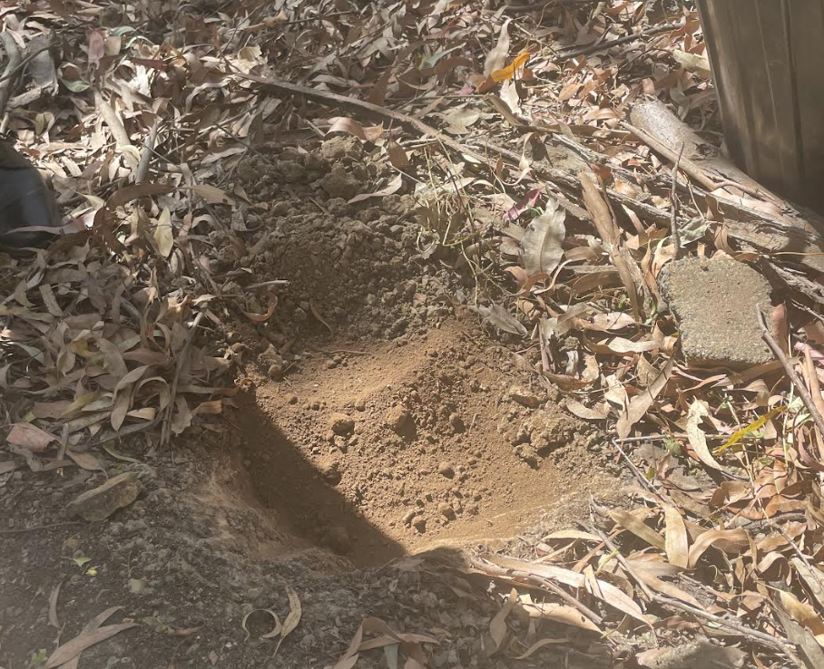 | -We added new soil as the soil that was originally there was dry and crumbly, which is not suitable for planting.
During | 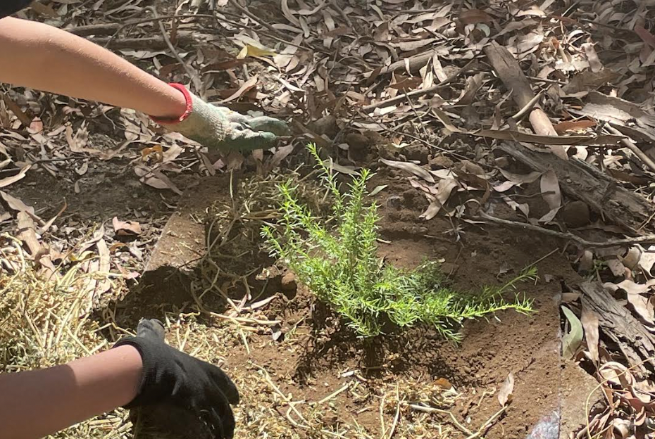 | -Ground armour is the name of the plant we planted in the erosion riddled area. This was selected as the root systems would spread to enable the soil to be maintained in the area (helping prevent erosion).  We replaced the soil, added mesh and hay, then planted the ground armour as a method of remediating the soil and to help prevent erosion.
After | 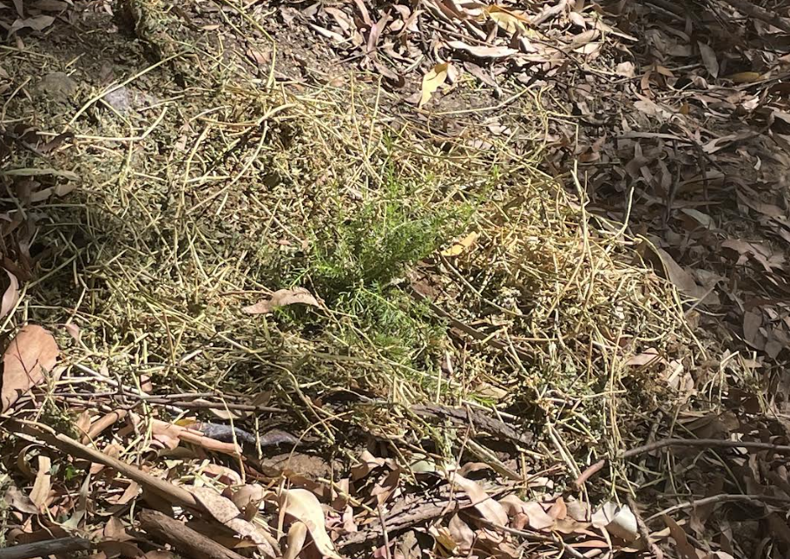 | Compared to the original planting site, the area appears to have increased in vegetation which is indicative of an overall improvement of the area's environmental health. This will assist the ecosystem surrounding the site to thrive and grow, with the support of new growth.
During watering | 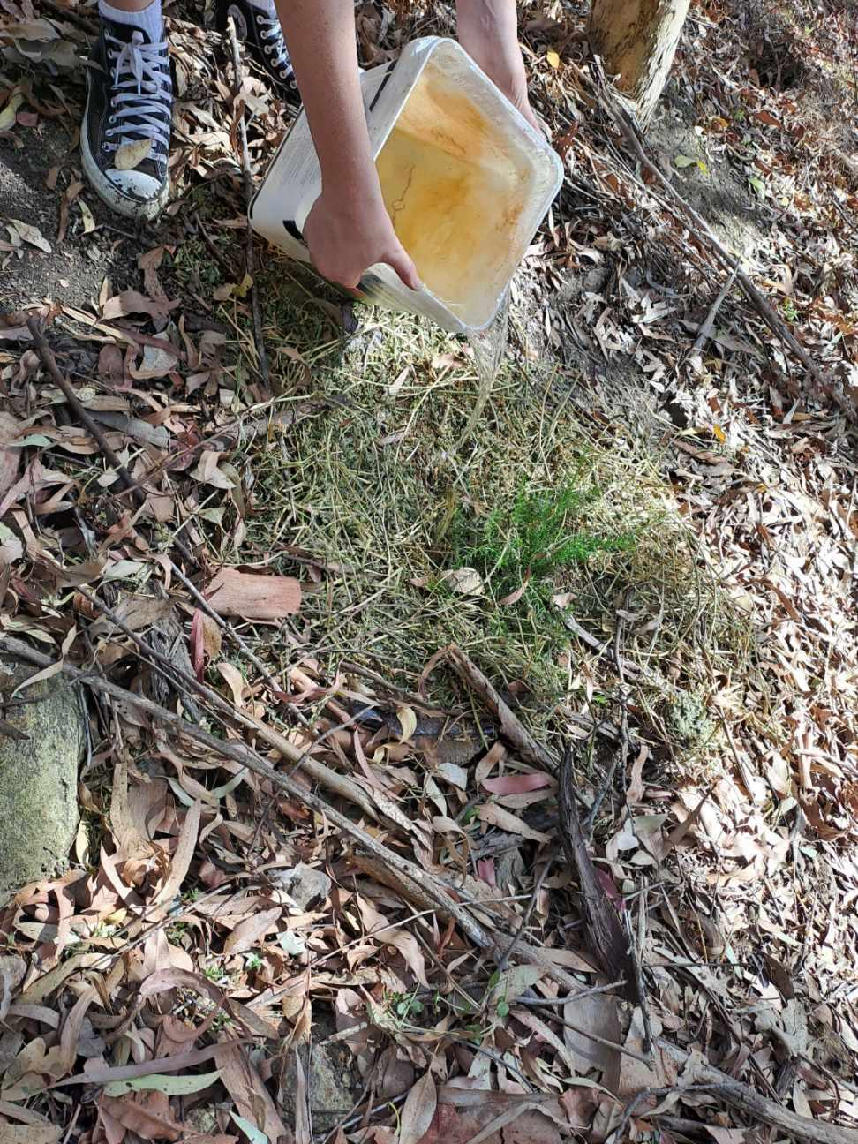 | - The plant absorbed the water and nothing washed away or moved from where we placed it.

Conclusion: Our soil analysis has highlighted that newly-established vegetation can be used as a preventative measure to avert further soil erosion within the environments at the school.

