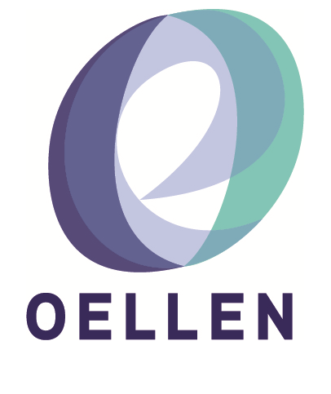

|  |  |
| --- | --- |
| **Free information evening for Students and Parents**   |  | | --- | | Did you know that Australian Apprenticeships and Traineeships can lead to  some amazing careers in over 500 different job areas?  Proudly supported by the Eastern Metropolitan Partnership, local employers  and TAFE, OELLEN is holding a free information session for young people looking for  alternative pathways to great jobs for the future.  Join us to hear about Apprenticeships, Traineeships and  TAFE pathways from a range of industry and vocational  training experts.  • What is an Apprenticeship or Traineeship?  • What are the advantages and current supports?  • What industry choices are available?  • How do I apply?  SKILLS for the FUTURE  • Projected job growth areas  • Industry trends and employer expectations  • Real-Life success stories from young people  This event is **FREE.** Bookings through Eventbrite. |   **Date: 24 October 2019 Time: 6.00pm – 8.00pm Location: Aunty Dot Peters Auditorium, Building LA,**  **Box Hill Institute Lakeside Campus**  **1 Jarlo Drive, Lilydale, 3140** |
|  |
|  |



Understanding Apprenticeships & Traineeships

**Click** [HERE](https://www.eventbrite.com.au/e/understanding-apprenticeships-traineeships-tickets-72036935413?utm_campaign=postpub&utm_medium=em&utm_source=sm&utm_content=viewevent) **to book through Eventbrite**

**For further information contact OELLEN**

**OELLEN**

**(03) 8578 6844**

**www.oellen.org.au**

**info@oellen.org.au**