Family Service of Carols
A short service of Carols, readings and prayers
Tuesday 4December
6.00 – 7.00 pm
In the Amphitheatre (outside the music rooms)
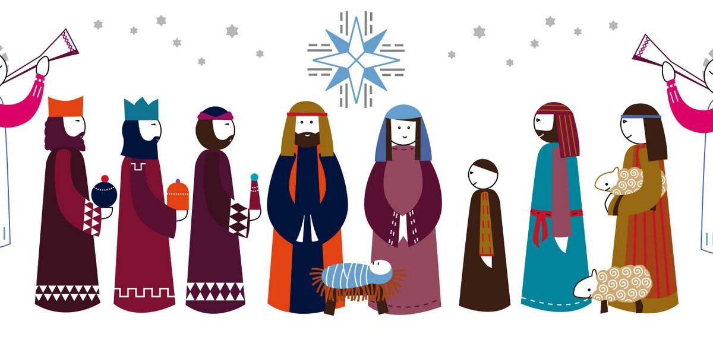
An informal gathering but a great way to start preparing for Christmas

Come along and bring the family and a picnic or have a complimentary sausage from the BBQ.
Dress the children as shepherds, angels or kings.
Candles and Carol Booklets on sale.

