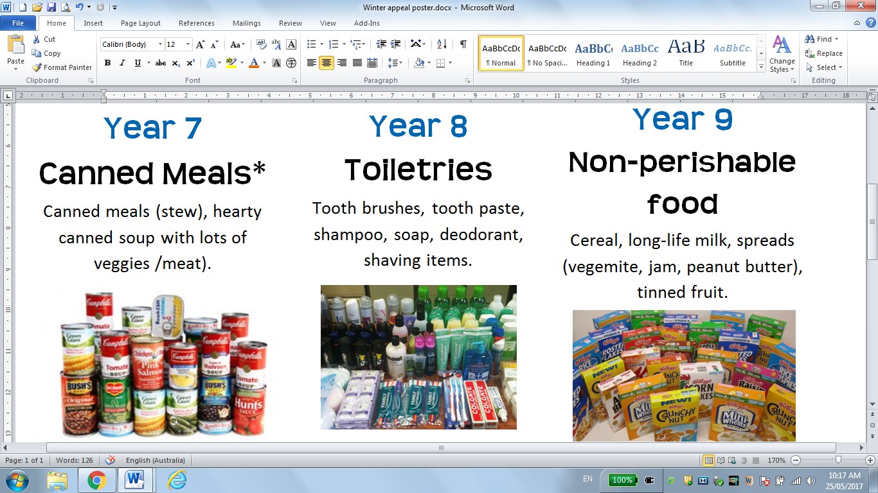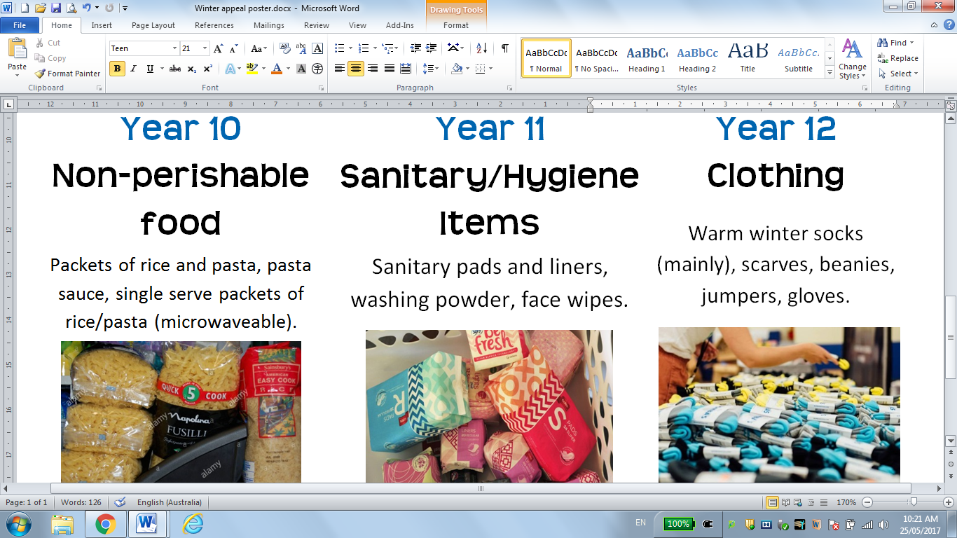

Collecting until end of term

**\*Ring-pull cans are preferable.  
Please ensure donations are well within their use by date.  
Students who cannot bring items from their year level category may bring anything listed above.**